**Water footprint assessment for wastewater treatment: method, indicator and application**

Ling Shao, and G.Q. Chen

*Environ. Sci. Technol.*, **Just Accepted Manuscript** • DOI: 10.1021/es402013t • Publication Date (Web): 18 Jun 2013

**Downloaded from** [**http://pubs.acs.org**](http://pubs.acs.org/) **on June 19, 2013**

**Just Accepted**

“Just Accepted” manuscripts have been peer-reviewed and accepted for publication. They are posted online prior to technical editing, formatting for publication and author proofing. The American Chemical Society provides “Just Accepted” as a free service to the research community to expedite the dissemination of scientific material as soon as possible after acceptance. “Just Accepted” manuscripts appear in full in PDF format accompanied by an HTML abstract. “Just Accepted” manuscripts have been fully peer reviewed, but should not be considered the official version of record. They are accessible to all readers and citable by the Digital Object Identifier (DOI®). “Just Accepted” is an optional service offered to authors. Therefore, the “Just Accepted” Web site may not include all articles that will be published in the journal. After a manuscript is technically edited and formatted, it will be removed from the “Just Accepted” Web site and published as an ASAP article. Note that technical editing may introduce minor changes to the manuscript text and/or graphics which could affect content, and all legal disclaimers and ethical guidelines that apply to the journal pertain. ACS cannot be held responsible for errors or consequences arising from the use of information contained in these “Just Accepted” manuscripts.

Water footprint assessment for wastewater treatment: method, indicator and application

*Ling Shao, G.Q. Chen\**

State Key Laboratory of Turbulence and Complex Systems, College of Engineering, Peking University, Beijing 100871, China

## ABSTRACT

The water footprint in terms of the sum of both direct and indirect water cost of wastewater treatment is accounted for the first time in this paper. Based on the hybrid method as a combination of process analysis and input-output analysis, a detailed water footprint accounting procedure is provided to cover the supply chain of a wastewater treatment plant. A set of indices intending to reveal the efficiency as well as renewability of wastewater treatment systems are devised as parallels of corresponding indicators in net energy analysis for energy supply systems. A case study is carried out for the Beijing Space City wastewater treatment plant as a landmark project. The high WROI (water return on investment) and low WIWP (water investment in water purified) indicate a high efficiency and renewability of the case system, illustrating the fundamental function of wastewater treatment for wastewater reuse. The increasing of the wastewater and sludge treatment rates is revealed in urgent need to reduce the water footprint of China and to

improve the performance of wastewater treatment.

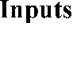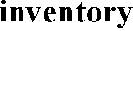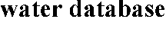

**TOC/Abstract art**

# INTRODUCTION

Water footprint, also regarded as virtual water or embodied water, is defined as the volume of total freshwater directly and indirectly required to produce a commodity or service.1 Given the rapidly growing water consumption and water resources scarcity, abundant studies on water footprint accounting have been carried out.2-8 Wastewater treatment plays a vital role in people’s daily life as to purify the wastewater and discharge ready-for-reuse water to human society. Due to its significant ecological implication in water reuse, the resource uses and environmental emissions of wastewater treatment are quantified in different categories, such as greenhouse gas emission, energy consumption and land use.9-11 However, no study on assessing the water footprint as an important indicator of a specific wastewater treatment system has been reported yet. In a few

studies, the input-output analysis, as a top-down method comparing to the process analysis, has been relied on to calculate the average water footprint of the water industry within a nation or region.8, 12 These studies are considered meaningful and helpful to guide the policy making on industry level. Subjected to the aggregation level of statistic data, however, most of input-output analyses can only give an average sector resolution and usually do not allow for detailed discussions of a specific product, especially industry-atypical products. At the meantime, in most countries wastewater treatment is not listed as an individual industry in relevant statistics, which prevents us from assessing the water footprint of wastewater treatment just based on input-output analysis.

Under these circumstances, the accounting of the water footprint of a specific wastewater treatment system is performed for the first time in this paper. A process-based method supported by the averaged macro-economy data provided by input-output analysis (termed as the hybrid method hereafter) is employed to estimate the water footprint of a specific wastewater treatment system. The hybrid method has many successful applications in assessing environmental impacts of various systems including the wastewater treatment plant after its proposal in l970s.11, 13-15 It is employed not only to avoid the systematic truncation errors inherent in process analysis, but also to make the input-output analysis applicable for specific micro systems.

Based on the calculation of water footprint, a comprehensive evaluation of purification efficiency and renewability of wastewater treatment necessitates some

indicators. A wastewater treatment plant is exactly like the energy supply system with regard to the fact that their common essence is to deliver available resources to human society. As the net energy analysis is a mature and wildly used method to compare the amount of total energy directly and indirectly required by an energy supply system to the energy it has delivered,13 the proposed indices can be transplanted to assess the water purification efficiency of a wastewater treatment system. As a renewable system of water recourse, the renewability assessment of wastewater treatment can also draw lessons from the cases of renewable energy technologies, of which the renewability has been extensively discussed in the last decade.16, 17

This paper aims at providing an explicit accounting procedure to calculate the water footprint as an environmental impact of a wastewater treatment system. A set of indices are also devised to reveal the purification efficiency and renewability of a wastewater treatment system. Besides the practical implication in providing clear guidance for designing water saving strategies as well as prioritizing options of wastewater treatment technologies, this study can also contribute to estimation of water footprint of wastewater treatment industry in China. In order to demonstrate the method, a case study has been carried out by systematically calculating the water footprint of a typical conventional wastewater treatment system in Beijing on the basis of detailed inventories and latest embodied water intensity database for the Chinese economy.

# METHODS AND MATERIALS

## The hybrid method

The process analysis as a bottom-up method has been relied on to trace individual environmental impact of a wastewater treatment plant through its lifecycle by a lot of studies.9, 10 Although it can provide detailed process information, it is time-consuming and has been suffered from the truncation error. The input-output analysis is a top-down method comparing to the process analysis. It is relatively fast and deemed to be complete as can model all transaction activities within an economy. However, due to the high level of aggregation in industry or commodity classifications of input-output table, the results of input-output analysis is often too rough for concrete assessments of some particular technologies or products in an economic sector. Therefore, the hybrid method intending to combine the strengths and reduce the weaknesses of both methods has been advocated. So far there are several alternative models of the hybrid method, e.g., tiered hybrid analysis, input-output based hybrid analysis and integrated hybrid analysis.18, 19 The simplest model of tiered hybrid analysis contributed by Bullard et al.13 is adopted in this study. The approach is simple, quick, and does not require any additional data.18 By more or less modification of the input-output table, other hybrid methods are complex and suffer from high data requirements,20 which are far from realizable in water footprint accounting, especially for the assessment of wastewater treatment in China.

To evaluate the virtual water of an individual wastewater treatment system reflected

by some process model as a micro-system in the macro-economy, the indirect fluxes originated outside the process boundary can be well traced by averaged sectoral intensities provided by proper input-output analysis of the economy. A wastewater treatment plant shares a tiny part of the whole wastewater treatment industry, which would avoid the possible double counting of tiered hybrid method. The simplest model of the tiered hybrid analysis assumes that the product of interest is well approximated by its industry sector. Therefore the water footprint of an input can be easily obtained by simply multiplying the monetary cost to the water footprint intensity of the sector.

## Diagram for water footprint assessment of a wastewater treatment system

The freshwater withdrawal during the whole lifetime of the wastewater treatment system is set as the accounting goal of this study. Besides the usual functional unit as 1 m3 of treated wastewater, the water footprints of 1 kg removed pollutant (BOD and COD) and of ten thousand Chinese Yuan (1E+04 CNY) output value are also calculated. Water footprint assessment for a wastewater treatment system is diagrammed in Figure 1. As shown in the figure, the inputs of wastewater treatment are classified into three categories as material inputs, machinery inputs and tap water inputs. Material inputs are directly provided by other industries and consumed by wastewater treatment. The water footprint of material inputs are the virtual water content of the products. The machinery refers to the involved equipment that can be used in other place. For instance, the rooter and truck used to dig and delivery soil in construction stage are machineries. But the pump and

aerator used to draw and aerate wastewater during the operation stage are materials. By assuming that the virtual water embedded in the machinery is uniformly distributed along its lifecycle, the water footprint of machinery inputs can be estimated as the water footprint of the product times its work time and divided by its total life time.21 The life time here indeed refers to the total work time. As for the fuel consumption of machinery, they are classified as materials.

Tap water is indeed a kind of material input. It is listed as a distinctive category to avoid possible misunderstanding by simply regarding the volume of tap water as its water footprint in water footprint accounting. Tap water is the typical and major product of water supply industry which needs a lot of inputs from other industries in its production just like the secondary energy. Therefore water footprint of tap water should be the virtual water embodied in its life time, not its direct water volume. The data source of inputs inventory of the wastewater treatment system should be reliable and exhaustive. A

first-hand project data provided by the builder is preferred.

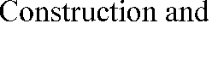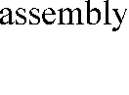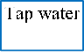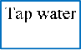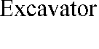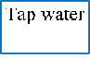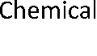

**Figure 1. Diagram for water footprint assessment of a wastewater treatment system**

## Procedure of water footprint assessment for a wastewater treatment system

By employing the hybrid method as an integration of process analysis and input-output analysis, the framework of water footprint assessment for wastewater treatment can be established as follows.

1. Itemize all the materials, machinery and tap water inputs required in the construction, operation and demolition stages to form the inputs inventory of the wastewater treatment system. As the embodied water intensity, i.e., the water footprint or the

virtual water content of each input product provided by input-output analysis is in the unit of m3 / 10,000 CNY, the monetary cost (*Cj*) of the *j*-th input should be listed in the inventory.

1. Choose an appropriate embodied water intensity database for all inputs. To avoid the truncation error of process based analysis when tracing each process linked to a specific product in the network of the economy, the database obtained from

input-output analysis is necessary here to support a comprehensive and accurate research. The economy input-output table as the fundamental data source of input-output analysis is updated every fixed time period, five years in China for instance. So it is essential to choose a database whose publishing year is in accordance with the year when the wastewater treatment system was built.

1. Identify the corresponding production sector for each item of the inventory with reference to statistical methods for economy input-output table provided by the national or regional statistics. The corresponding embodied water intensity (*Ij*) of each input can be derived from the database promptly. For example, pumps are produced by sector 67 (manufacture of pump, valve and similar machinery) in the Chinese economy 2007, so the embodied water intensity of pumps is determined as the intensity of sector 67 listed in the database. This step may involve some extra efforts. For example, some inputs from the same industry and having the same embodied water intensity may be combined to simplify the account.
2. Multiply each item’s cost by its embodied water intensity to give the water footprint (*WFj*), then the total water footprint (WF) of a wastewater treatment system is readily obtained as

WF  *WF*j  (*Cj*  *I j* ) .

*n n*

*j*1 *j* 1

## Water footprint indices for assessing purification efficiency and renewability of a wastewater treatment system

As mentioned in the introduction, the water footprint as the virtual water cost of a wastewater treatment system is analogous to the energy cost of an energy supply system and the indices developed in energy analysis can be transplanted here. Among all the indices provided by net energy analysis to reveal the conversion coefficients of energy supply systems, the NE (net energy) denoted as the energy gained and EROI (energy return on investment), denoted as the ratio of the energy extracted or delivered by an energy supply system to the energy consumed directly and indirectly in its supply chain, are regarded as the most basic and representative indices since 1970s.22, 23 The indices of NW (net water) as the net water purified and WROI (water return on investment) as the ration of the water purified by a water treatment system to the water required, i.e., water footprints of the system are therefore suggested here in this paper (see Table 1).

**Table 1**

**The indices of an energy conversion system and a wastewater treatment system**

Renewable energy sources, such as biofuel, solar power and wind power, have been developed to reduce the fossil fuel cost and thus mitigate the greenhouse gas emission since the end of the last century. While energy efficiency indicated by EROI remains meaningful, it does not suffice to evaluate the renewability of renewable energies. Chen et al.24 suggested an indicator of NEIED (nonrenewable energy investment in energy delivered), defined as nonrenewable investment in energy delivered to address how much nonrenewable energy instead of inclusive energy is consumed to produce a presumed

renewable energy. Wastewater treatment is devised as a water reuse technology for renewing polluted water resources. Renewability is among the most fundamental properties of a wastewater treatment system. The index as WIWP (water investment in water purified) is therefore utilized to assess the renewability of a wastewater treatment system (see Table 1). From the definition, it can be known that a low WIWP is preferred.

## Case description and data source

The rapid economy growth and accelerating urbanization of China have a profound impact on the availability of China’s natural resource, especially the water resource. The water scarcity tension is extremely prominent in most cities in Northern China, due to a series of factors such as unbalanced spatial distribution, large population and heavy water pollution. Against this background wastewater treatment becomes one of the most promising technologies. Projected in early 1990s, Beijing Space City (BSC) is located in Haidian District, northwest of Beijing, which is far from the downtown of Beijing and thus is out of the municipal wastewater pipe network. With so many research institutes and accompanied life centers entering in, the wastewater becomes a critical problem for creating a graceful environment of BSC. Against this background, a wastewater treatment plant (WWTP) was designed and constructed here by the Environment Design and Research Center of the Chinese People's Liberation Army in 2007 to deal with the wastewater of BSC.25 The case system lies in the north (1.4km) of BSC and has a

designed daily treatment capacity of 7200 m3. It employs a Cyclic Activated Sludge System (CASS) to treat the wastewater.26 A brief introduction of the CASS and a detailed description of the case system can be found in the Support Information (SI), Section 1.

It is recommended that a database adapted to the place and year where and when the wastewater treatment plant was built should be the priority. Our case system is located in China and was built in 1998. However, in that year Chinese Government did not publish economy input-output table. Among the very few input-output tables available, the table of Chinese economy in 2007 is the latest and most detailed economy input-output table published by National Bureau of Statistics of China. A previous work contributed by Chen and Chen12 has already calculated the water footprint intensity database for the Chinese economy in 2007 based on it (SI, Section 2). It is adopted in this study as the supporting data. Only water use instead of water consumption data are available in China Statistical Yearbook, and the water usage has been classified as agricultural water, industrial water, domestic water and municipal ecological protection water.27 Chen and Chen12 have simplified the assortment by categorizing the water resources as agricultural water (with reference to agricultural water only) and industrial water (with reference to industrial water, domestic water and municipal ecological protection water) in their work. The Producer Price Indices of Industrial Products (PPI) of China is referred to convert the construction cost of construction year-based into 2007-based (SI, Section 3).28

# RESULTS AND DISCUSSION

## The water footprint of the case system

Only the water footprints of construction and operation stages are accounted with that of the demolition stage ignored. The designed life time of BSCWWTP is set as 20 years in accordance with usual practice of China. The inputs inventory accompanied with their corresponding input-output sectors is listed in Table S4 of SI. As mentioned in Section 2, the simplest model of tiered hybrid analysis which assumes that the product of interest is well approximated by its corresponding industry sector is employed in this study. It can be seen that each input is the typical product of its production industry.

Therefore, the method is reasonable and reliable and will not bring much inaccuracy to our results. In earlier life cycle environmental impacts studies of a wastewater treatment system, their inputs were traced to a raw material base.10 It may cause errors to the final results since the assemble processes of purchased products also involve extra impacts. For example, the water footprint intensities of steel and pump are quite different.

The calculations of the water footprint of BSCWWTP are shown in Table 2, with some inputs from the same production sector and having the same intensity merged for convenience.

The water footprint of BSCWWTP is estimated as 1.64E+05 m3 freshwater, with intensities of 3.12E-03 m3 freshwater/m3 wastewater, 1.33E-02 m3 freshwater/kg BOD5, 1.04E-02 m3 freshwater/kg COD and 3.90E+01 m3/10,000 CNY. The components of the water footprint of BSCWWTP are shown in Figure 2. The electricity accounting for more than one half is the largest source of water footprint. Energy saving practice has been promoted all over the world since decades ago. According to the results, energy saving policy should be further enhanced for wastewater treatment as a high energy-consuming industry, due to its equal importance for water footprint reduction.

As the second largest water footprint source, the tap water accounts for about 10% of the total water footprint. The direct water consumption, i.e., the volume of tap water, is less than 3% of the total water footprint of the case system, which strongly demonstrates the importance and essentiality of water footprint account. The real water content (4365 m3) of tap water is only 25% of its virtual water content (1.69E+04 m3). The civil work consisting of the construction of basins and tanks shares 13.24% of the total water footprint, followed by the equipment with a total contribution of 7.56%.

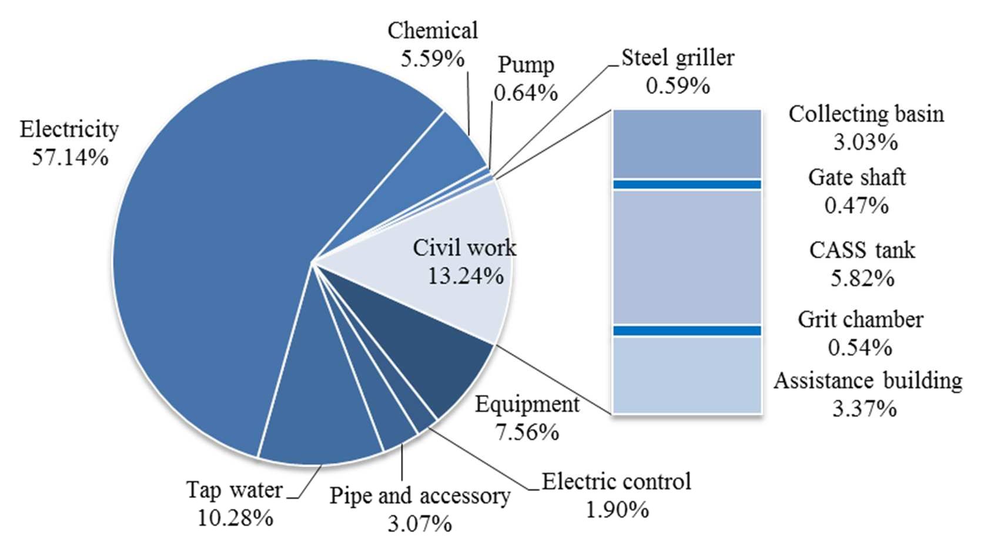

**Figure 2. The components of the water footprint**

The contrast between the two categories of water footprint as agricultural and industrial water footprint during the construction and the operation stages for the case system is shown in Figure 3. Due to the data availability, only the electricity and chemicals are concerned for the operation stage while other inputs such as the maintenance of the plant are ignored. Even so, the water footprint in the operation stage is larger than that in the construction stage. The result is in good accordance with a lot of former studies showing that the environmental impacts of the operation stage are much greater than that of the construction stage for wastewater treatment systems.11, 29, 30

The difference between operation stage and construction stage is mainly from the industrial water. It can be seen that the wastewater treatment dependents more on

industrial products than agricultural products. Almost nothing in inputs inventory of case system is directly from Agricultural industry, but the percentage of agricultural water as 16.57% is still considerable. It clearly shows the connection between primary and secondary industries. In contrast to abundant studies on estimating the water footprint of agricultural products, the water footprint of industrial products has seldom been paid attention to. It should be enhanced in the future since the close interactions of different

industries are associated with water footprint exchanges.

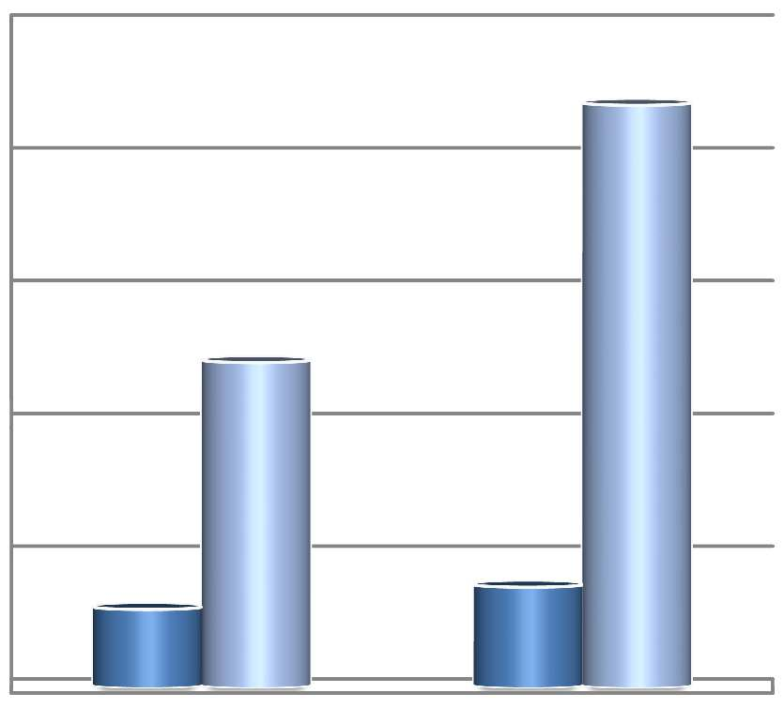

1.00E+05

8.00E+04

6.00E+04

Agricultural water

4.00E+04

Industrial water

2.00E+04

0.00E+00

Construction

Operation

**Figure 3. The water footprint of construction and operation stages of BSCWWTP**

## The efficiency and renewability of the case system

The NW and WROI of BSCWWTP are calculated as 5.24E+07 m3 in its whole lifetime and 3.20E+02 m3 purified water/m3 invested water. The WROI in this study is much larger than the EROI of energy supply systems (usual less than 100), indicating a

high efficiency of wastewater treatment. However, the EROI for energy system is becoming smaller day by day due to the increasing difficulty in fossil energy extraction. For example, the running average EROI for the finding and production of US domestic oil has dropped from greater than 100 in the 1930s to about 30 in the 1970s and to 11~18

nowadays.31 The freshwater withdrawal will become more and more difficult in the future. Also, the base pollutants concentration of freshwater would increase as a result of the continuous pollution caused by human activity. Therefore, the WROI of wastewater treatment would be expected to decrease in the future, too.

Water resource is deemed as a renewable resource and has a wide range of renewable spans. It can be either renewed through natural processes or purified by manmade wastewater treatment. But a wastewater treatment system has its own water footprint. Only when its water footprint is less than its purified wastewater can a wastewater treatment system be regarded as a renewable water system. Moreover, the renewable degrees are different among different wastewater treatment technologies, which can be assessed by the indicator of WIWP. For renewable energy systems, NEIED

< 1 means that more energy is produced than nonrenewable energy invested, while NEIED > 1 means that more nonrenewable energy is consumed than energy produced.24 The same meaning has been transplanted to the index of WIWP. The WIWP of the case system is calculated as 3.12E-03 m3 freshwater/m3 purified water, which is much less than 1 and indicates a high renewability of the case system. This finding coincides with

the fact that wastewater treatment is widely devised as an effective water reuse technology.

## Comparison between this study and some other water footprint accounting studies

Hoekstra and Chapagain (as well as their fellows) have made significant contribution by systematically classifying the water footprint as blue water footprint, green water footprint and grey water footprint. This perspective of classification emphasizing the scarcity of water resource has contributed significantly by providing clear guidance for prioritizing options of water footprint reduction. In earlier water footprint studies, only used water resources were concerned as blue water and green water. They refer to surface or ground water and freshwater brought by rain, respectively. Later this concept was extended by quantifying the impacts of pollution from the quality aspect. The grey water was then proposed and defined as the volume of freshwater required to assimilate the already generated pollutants to meet the existing ambient water quality standards.32 Such definition was derived from the concept of ecological footprint which transforms the environmental emission to the land area needed for uptake of the emission. It is not to mean that people are going to dilute the pollutants, but to provide an indicator to measure the pollution.1

Due to the data availability, only blue water footprint is accounted for the case system.

Meanwhile the implication of wastewater treatment in eliminating the grey water is discussed. There are two calculation methods of water footprint. In most bottom-up process analysis based water footprint studies, especial the water footprint accounting of agricultural products, only consumptive water use, e.g., evaporation is concerned.32, 33 It can either be estimated by field measurement or some empirical estimation methods. In contrast to this, in most top-down based studies, especial the water footprint accounting of industrial products, the total water use, e.g., the irrigation or withdrawn water is concerned.4, 8 It is due to the fact that available statistics of countries and regions only provide total water withdrawals. The databases that contain typical data on consumptive water use for various types of manufacturing processes do hardly exist. Some studies have made strong assumptions to relate the water withdrawal to consumptive water. For example, in Mekonnen and Hoekstra’s work to calculate the water footprint of agricultural and industrial commodities of each country, it is assumed that 5% of the water withdrawn for industrial purposes is actual consumption (blue water footprint) and that the remaining fraction is return flow; for the domestic water supply sector a consumptive portion of 10% is assumed.33 The presented study only concerns the water withdrawal, and the result (3.90E+01 m3/10,000 CNY) is more than three times larger

than that of aforementioned study concerning the consumptive water (9.82 m3 /1000 US $, average blue water footprint of China during 1996-2005). It reveals the gap between

consumptive water and withdrawal water studies. Attention to this issue should be paid in future water footprint accounting studies.

Hoekstra et al.1 stated that wastewater treatment can bring grey water footprint down.

However, the process of wastewater treatment has its own water footprint. The determination of the water footprint of wastewater treatment should be the premise to quantify its real contribution in eliminating the grey water footprint. By assuming that the natural concentration is zero and the maximum acceptable concentration in the receiving water body is as same as the concentration of effluent in this study, the grey water footprint eliminated by the case wastewater treatment system are calculated as 8.76E+08 m3 (BOD5) and 3.68E+08 m3 (COD) with reference to the grey water footprint theory (the equation can be found in SI, Section 4).1 Our case system does have a significant contribution in eliminating the grey water footprint (1.64E+05 m3 vs. 8.76E+08 & 3.68E+08 m3), which verifies the statement. Although the ignored green and grey water footprint of the case system may slightly diminish the contribution, the observed advantage is so outstanding that the superiority will not change.